**1**

Polar NRZ-L assuming bit rate is 4 kbps.

**Code and Simulations:**

% polar NRZ-L

% 22-47048-1

% AB-CDEFG-H

clc

clear all

close all

bit_stream = [0 0 0 0 0 1 0 0 1 0 0 0];

no_bits = length(bit_stream);

bit_rate = 4000; % 1 kbps

pulse_per_bit = 1; % for unipolar nrz

pulse_duration = 1/((pulse_per_bit)*(bit_rate));

no_pulses = no_bits*pulse_per_bit;

samples_per_pulse = 500;

fs = (samples_per_pulse)/(pulse_duration); %sampling frequency

% including pulse duration in sampling frequency

% ensures having enough samples in each pulse

t = 0:1/fs:(no_pulses)*(pulse_duration); % sampling interval

% total duration = (no_pulse)*(pulse_duration)

no_samples = length(t); % total number of samples

dig_sig = zeros(1,no_samples);

max_voltage = 5;

min_voltage = -5;

for i = 1:no_bits

if bit_stream(i) == 0

dig_sig(((i-1)*(samples_per_pulse)+1):i*(samples_per_pulse)) = max_voltage*ones(1,samples_per_pulse);

else

dig_sig(((i-1)*(samples_per_pulse)+1):i*(samples_per_pulse)) = min_voltage*ones(1,samples_per_pulse);

end

end

plot(t,dig_sig,'linewidth',1.5)

grid on

xlabel('time in seconds')

ylabel('Voltage')

ylim([(min_voltage - (max_voltage)*0.2)

(max_voltage+max_voltage*0.2)])

title(['NRZ - L for ',num2str(bit_stream),''])

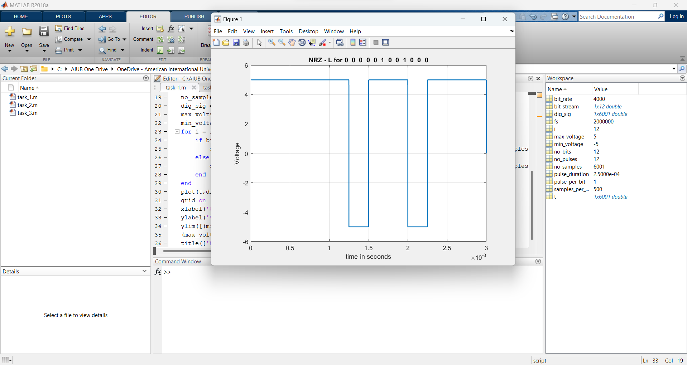

**2**

Manchester assuming bit rate is 2 kbps.

**Code and Simulations:**

% Manchester

% 22-47048-1

% AB-CDEFG-H

clc

clear all

close all

bit_stream = [0 0 0 0 0 1 0 0 1 0 0 0];

no_bits = length(bit_stream);

bit_rate = 2000; % 1 kbps

pulse_per_bit = 2; % for unipolar rz

pulse_duration = 1/((pulse_per_bit)*(bit_rate));

no_pulses = no_bits*pulse_per_bit;

samples_per_pulse = 500;

fs = (samples_per_pulse)/(pulse_duration); %sampling frequency

% including pulse duration in sampling frequency

% ensures having enough samples in each pulse

t = 0:1/fs:(no_pulses)*(pulse_duration); % sampling interval

% total duration = (no_pulse)*(pulse_duration)

no_samples = length(t); % total number of samples

dig_sig = zeros(1,no_samples);

max_voltage = 5;

min_voltage = -5;

for i = 1:no_bits

j = (i-1)*2;

if bit_stream(i) == 1

dig_sig((j*(samples_per_pulse)+1):(j+1)*(samples_per_pulse)) = min_voltage*ones(1,samples_per_pulse);

dig_sig(((j+1)*(samples_per_pulse)+1):(j+2)*(samples_per_pulse)) = max_voltage*ones(1,samples_per_pulse);

else

dig_sig((j*(samples_per_pulse)+1):(j+1)*(samples_per_pulse)) = max_voltage*ones(1,samples_per_pulse);

dig_sig(((j+1)*(samples_per_pulse)+1):(j+2)*(samples_per_pulse)) = min_voltage*ones(1,samples_per_pulse);

end

end

plot(t,dig_sig,'linewidth',1.5)

grid on

xlabel('time in seconds')

ylabel('Voltage')

ylim([(min_voltage - (max_voltage)*0.2)

(max_voltage+max_voltage*0.2)])

title(['Manchester for ',num2str(bit_stream),''])

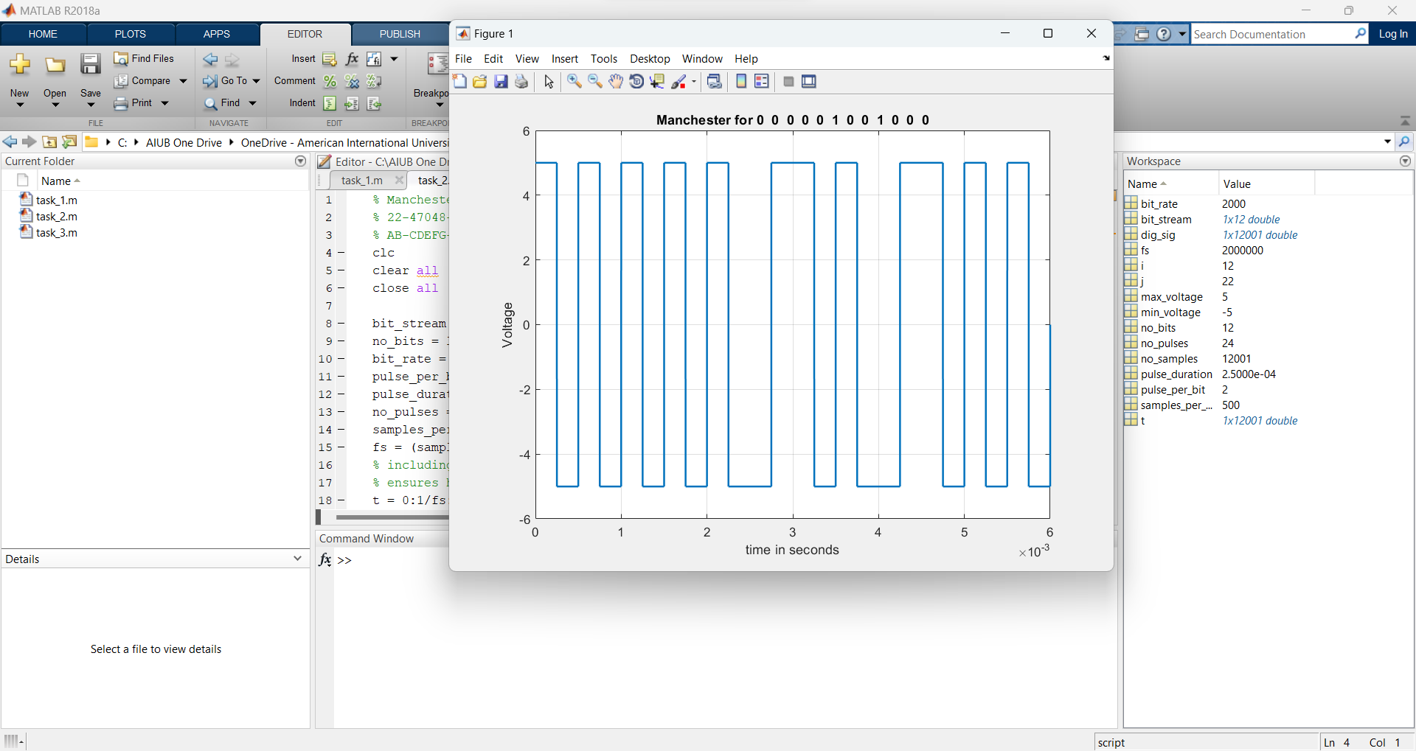

**3**

AMI assuming bit rate is 5 kbps.

**Code and Simulations:**

% AMI

% 22-47048-1

% AB-CDEFG-H

clc

clear all

close all

bit_stream = [0 0 0 0 0 1 0 0 1 0 0 0];

no_bits = length(bit_stream);

bit_rate = 5000; % 1 kbps

pulse_per_bit = 1; % for unipolar nrz

pulse_duration = 1/((pulse_per_bit)*(bit_rate));

no_pulses = no_bits*pulse_per_bit;

samples_per_pulse = 500;

fs = (samples_per_pulse)/(pulse_duration); %sampling frequency

% including pulse duration in sampling frequency

% ensures having enough samples in each pulse

t = 0:1/fs:(no_pulses)*(pulse_duration); % sampling interval

% total duration = (no_pulse)*(pulse_duration)

no_samples = length(t); % total number of samples

dig_sig = zeros(1,no_samples);

max_voltage = 5;

min_voltage = 0;

sign = 1;

for i = 1:no_bits

if bit_stream(i) == 1

dig_sig(((i-1)*(samples_per_pulse)+1):i*(samples_per_pulse)) = sign*max_voltage*ones(1,samples_per_pulse);

sign = (-1)*sign;

else

dig_sig(((i-1)*(samples_per_pulse)+1):i*(samples_per_pulse)) = min_voltage*ones(1,samples_per_pulse);

end

end

plot(t,dig_sig,'linewidth',1.5)

grid on

xlabel('time in seconds')

ylabel('Voltage')

% ylim([(min_voltage - (max_voltage)*0.2)

% (max_voltage+max_voltage*0.2)])

title(['AMI for ',num2str(bit_stream),''])

